4.10, 4.11 TEST MS
1. (a) (i)
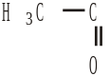 or RCOCH3; 1
(or description in words)
(ignore trailing bonds)
(ii) H3C—O or ROCH3; 1
(allow 1 if both (i) and (ii) give CH3–- or H3C– only)
(iii) CH2CH2 or two adjacent methylene groups; 1
(iv)
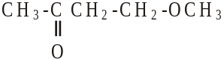
OR
CH3COCH2CH2OCH3; 1
(b) (i) OH in acids or (carboxylic) acid present
(ii)
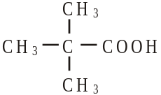
(c)
reagent | K2Cr207 /H+ | KMnO4 /H+
Y | no reaction | no reaction
Z | orange to green or turns green | purple to colourless  or turns colourless
5
[9]

2. (a) Pentan-2-one 1
(b) (i) 1680 – 1750 (cm–1) 1
(ii) 3230 – 3550 or 1000 – 1300 (cm–1) 1
(iii) 4 1
(c)
Reagent | K2Cr2O7/H+ | KMnO4 /H+ | Na | CH3COOH/  H2SO4 | 1
with C | no reaction | no reaction | no reaction | no reaction | 1
with D | goes green | goes colourless | effervescence | smell | 1
(penalise incomplete reagent e.g. K2Cr2O7 or Cr2O7 2–/H+ then mark on)

(d)
Reagent | Tollens | Fehlings or Benedicts | 1
with E | silver  (mirror) | red ppt or goes red  (not red solution) | 1
[9]
3. (a) A any C5 alkene 1
B
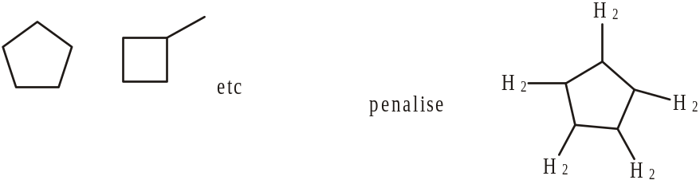 1
(b) C
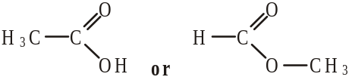 1
or CH3COOH or HCOOCH3
D
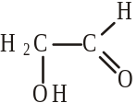 1
or HOCH2CHO
(c) E
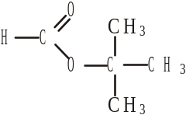 1
F
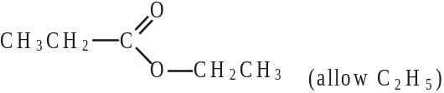 1
(d) G
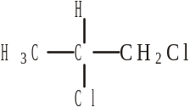 1
H
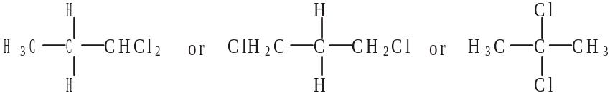 1

(e) I
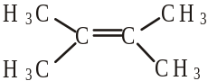 1
J
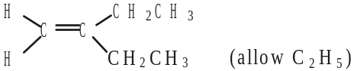 NOT hex-3-ene 1
[10]

4. (a) (CH3)4Si (1) 1
(b) 3 (1) 1
(c) 2 : 3 : 3 (1) 1

(d) methyl or CH3 (1) 1
(e) Group ethyl or CH2CH3 or C2H5 (1)
Explanation CH3 splits CH2 → quartet or 4 peaks (1)
CH2 splits CH3 → triplet or 3 peaks (1) 3
(f) C = O (1) 1
(g) Peak at m/z = 43 CH3CO+ or [CH3CO]+ (1)
Peak at m/z = 57 CH3CH2CO+ or [CH3CH2CO]+ (1) 2
(h) CH3COCH2CH3 (1) 1
[11]

5. (a) (i)
Reagent | Tollens | Fehlings or Benedicts | K2Cr2O7/H+  or acidified | KMnO4/H+ | I2/Na0H
Propanal | silver (mirror) | red ppt or goes red  (not red solution) | goes green | goes colourless | No  reaction
Propanone | no reaction | no reaction | no reaction | no reaction | Yellow  (ppt)
(penalise incomplete reagent e.g. K2Cr2O7 or Cr2O72–/H+ then mark on)
3
(ii) propanal 3 peaks ignore splitting even if wrong 1
propanone 1 peak 1

(b) X is CH3CH2COOH or propanoic acid if both name and formula given, 1
both must be correct, but
Y is CH3CH(OH)CH3 or propan-2-ol allow propanol with correct formula 1
Mark the type of reaction and reagent/condition independently.
The reagent must be correct or close to score condition
Step 1 Oxidation 1
K2Cr2O7/H+ or other oxidation methods as above
allow Cr2O72–H+ if penalised above (ecf)
reflux (not Tollens/Fehlings) or heat or warm

Step 2 | reduction or nucleophilic  addition | reduction or  nucleophilic addition | reduction or hydrogenation | 1
 | NaBH4 | LiAlH4 | H2 | 1
 | in (m)ethanol or water or ether  or dry | ether or dry | Ni / Pt etc | 1

Step 3 esterification or (nucleophilic) addition-elimination or condensation 1
(conc) H2SO4 or HCl 1
warm (allow without acid reagent if X and Y given as reagents) 1
or reflux or heat 1
[15]

